Continuous Delivery

1. In the continuous Integration we will get the artifacts and we need to deploy that artifacts in various hosting services
2. For that we need continuous Delivery pipeline
3. There should be NO shortcuts and when we are doing the process first time and we need to repeat the process second and third time and so on.. and we need to figure out the way if even though the process is difficult and need to do every time
4. Everything should come from GIT hub or Azure repos (source control)
5. Done means software is released and it is gone into production machine
6. In CI we have code coverage and sonar cloud and in the same way we are going to do in CD also
7. Quality is never postponed it is part of build pipeline
8. We no longer work in the isolation and all teams must be include
9. Before moving the artifacts into production, it will go various stages like Dev, UAT
10. We can publish the code very easily just Right click and publish the code (which we will do in the dotnet (visual studio) and java(eclipse)
11. However, the code has NO guarantee because it was not properly tested
12. So, use the CD which will publish the artifact in respective environments
13. We want to create the CD pipeline and through the CD pipeline we want to publish the application into DEV, UAT and Production but what are those environments made up off
14. If we are taking about Azure in specific we have 4 hosting services
15. We can Use Azure App services ( PASS) service by deploying my application we need to put our application and Azure on behalf will manage the application and gives the simple options for achieving many things with least effort because it is a platform as service for example on my site load is more with few clicks I can scale the application I can do horizontal scaling and vertical scaling and I can probably have security build in at the app service layer so lot of readymade features are provided to the web application which are hosted as app services
16. In azure if you want to host the application in Virtual machines and virtual machine scale sets these are Infrastructure as service that means we want to create a VM before creating VM a virtual network with subnet and then between browser and VM we need to create manually load balancers the load balancers are where VMS are manually added so lot of hard work an IT Team has to do to get the application available to users and certain large scaling applications or applications which customization and VM and VM scale sets are ideal for lift and shift of the applications. When application is already running on premises and the same thing we need in cloud we can do lift and shift and applications and if the code is already present on premises and we don’t need any changes then we can do lift and shift of the applications
17. Serverless computing they are referred as server less computing because they are NOT assigned to dedicated resources the resources are assigned to Azure functions only when the function has to execute and for that there are some triggers associated with it the trigger can be a http trigger where once the message has received the function will execute that trigger also can blob when the triggers happen and the build will occur
18. Containers also called Docker Containers we can always host your application by creating first docker image and deploying in Docker container. Azure will give Azure container instance, or we can use containers through App service
19. We need some hosting environment the place where application is going to deployed so that it can consumed by various members on the internet
20. We need some physical machine or Virtual Machine, or we manage or either cloud provider will manage where we want to deploy our application
21. In DevOps it is NOT necessary to publish the application in Azure we can publish in AWS or google cloud or in on premises environment

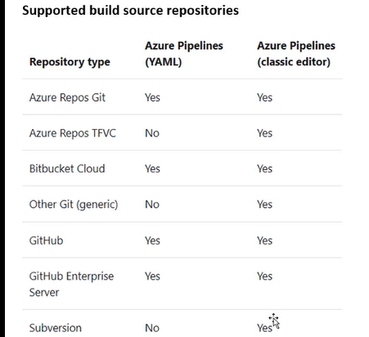

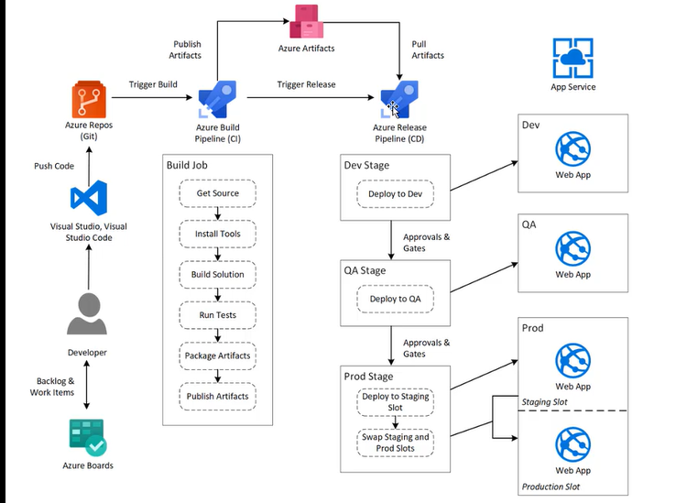

2-Creating Service Connection to Azure Subscription

1. Our pipeline will run on one machine and that machine we should have access to Azure
2. There are number of Roles like owner (he can do everything and also he can give permissions to others) , Reader(he can only read the existing properties) and contributor ( he will manage the resources he will create the resources, like he create app services, virtual machine he can create Virtual network, storage account however he cannot give permissions to others)etc., which is most common
3. How can we connect our pipeline to Azure? So, we need to login to Azure portal.com

We can check the subscription from the below navigation

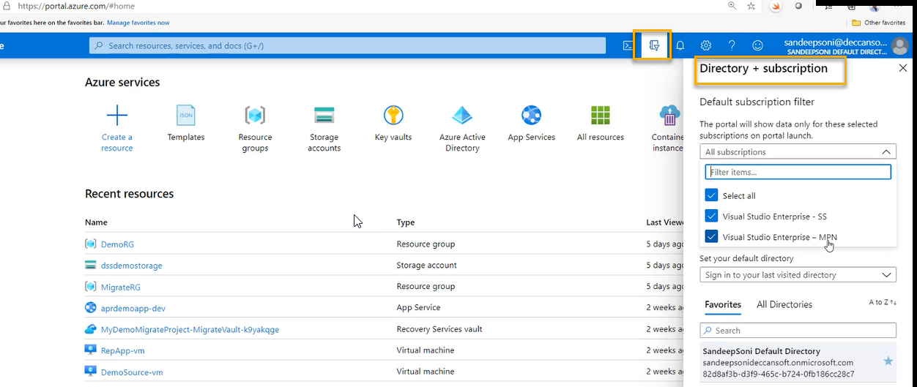

1. We need to create the service principle and assign to the pipeline (code)in order to get communication to Azure
2. In which ever organization you are with whatever identity you login to Azure DevOps compulsory we need to login with same credentials to Azure portal
3. I can go to my project

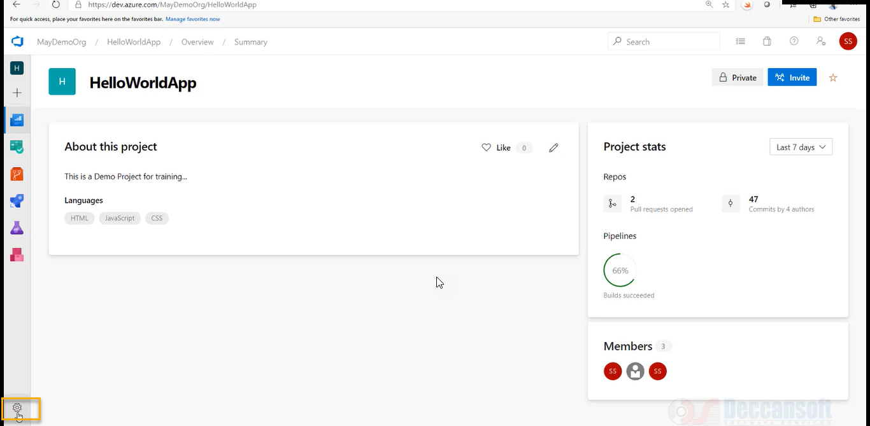

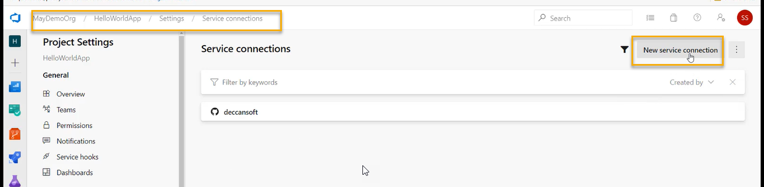

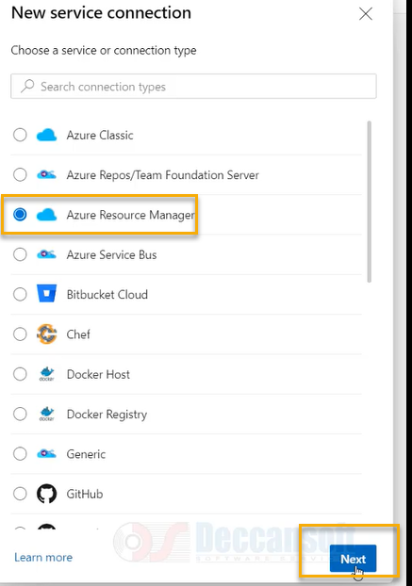

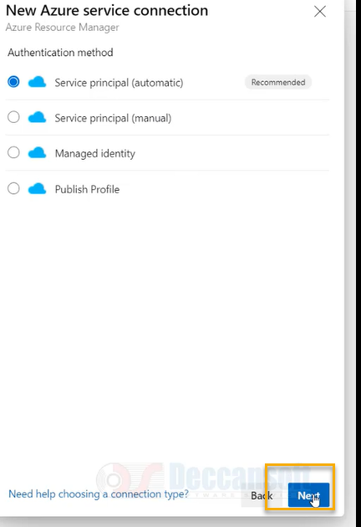

Resource group: If you give it blank then we can work with any resource group

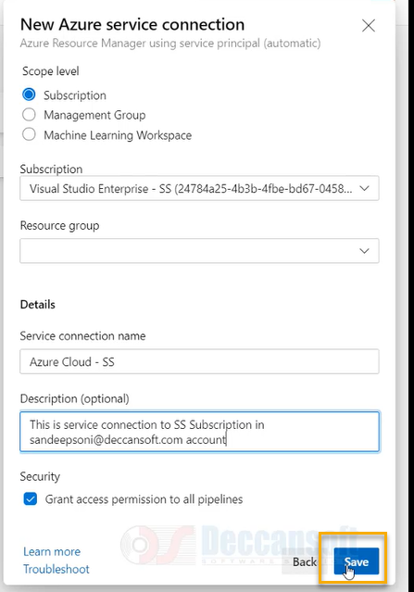

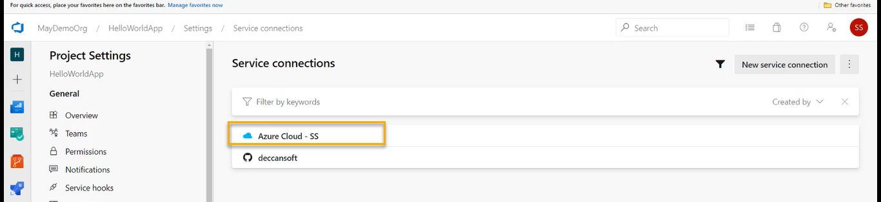

However, the credentials for both portal and Azure DevOps need to be same

Now go to Azure portal

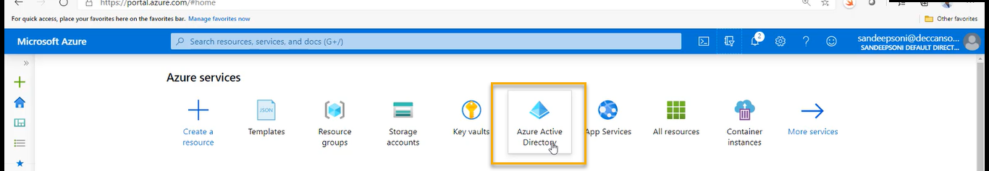

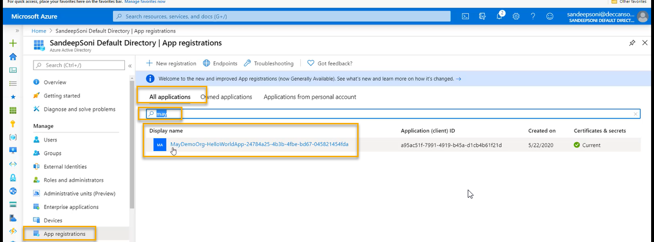

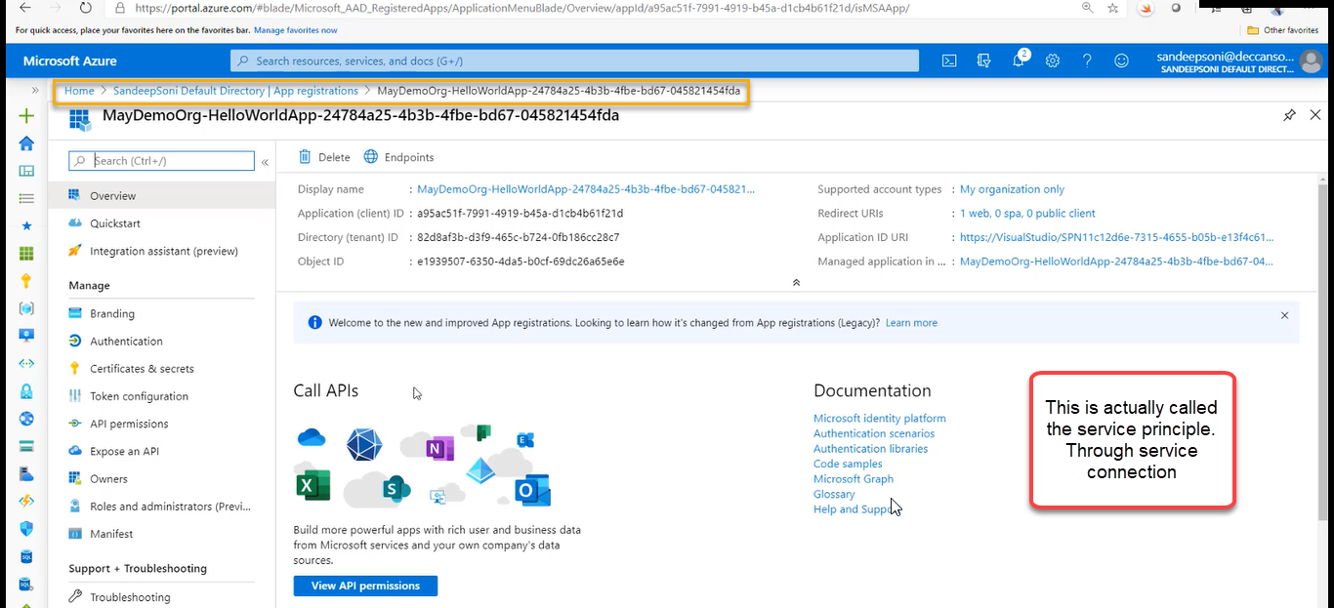

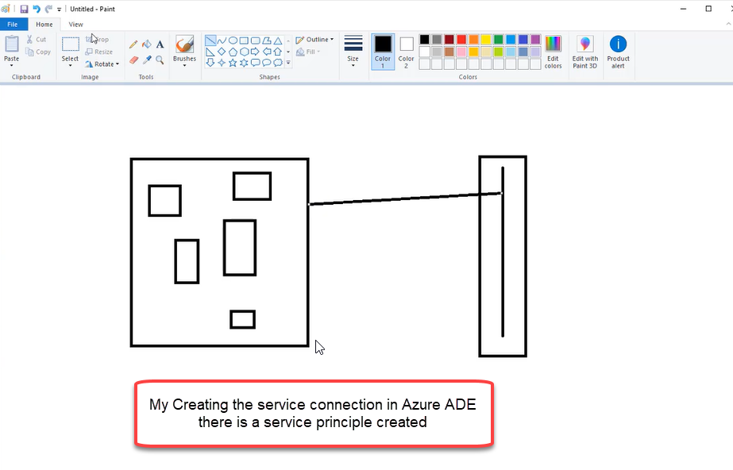

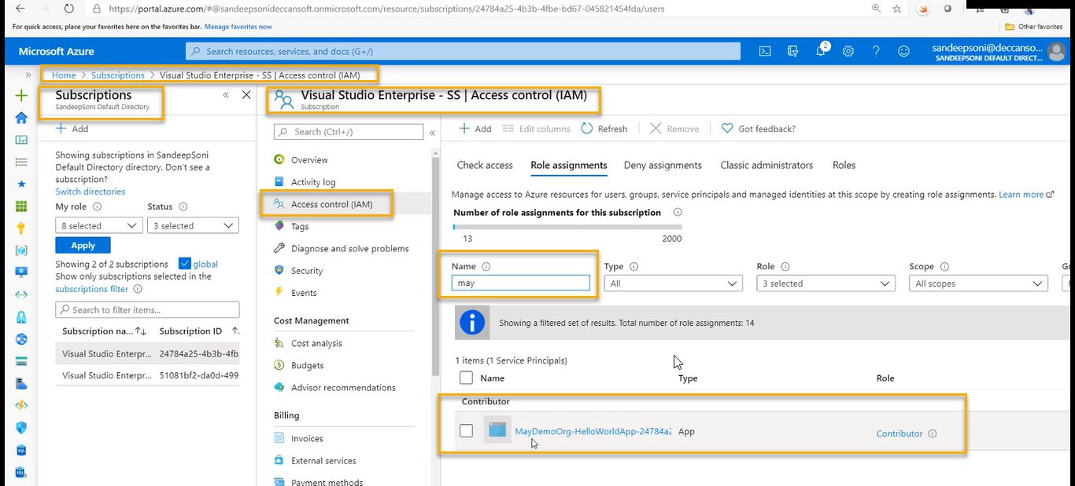

The project in Azure Devops will create the service principle in AD and this principle as granted as contributor role on the subscription

Hence under this subscription my pipeline can access all the resources and it can deploy any resource under the subscription now.

Because it is a contributor

As of now we are doing the connection from Azure DevOps to Azure portal/Directory as automatic and now we are going to see them manually





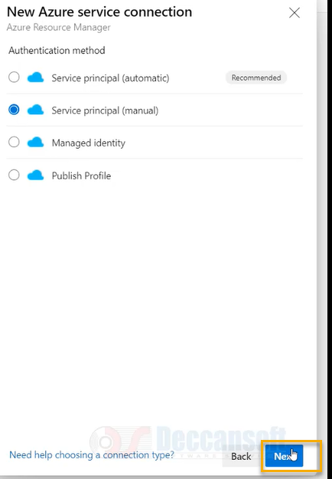

If you use manual, we need lot of information

We need below things in order to complete the process

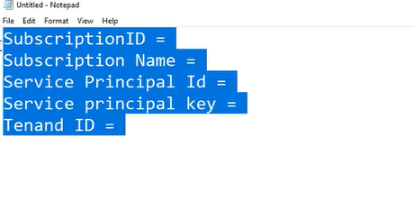

Most of the times the IT Admin will provide all the above things

And if your IT Admin then? Go the below steps

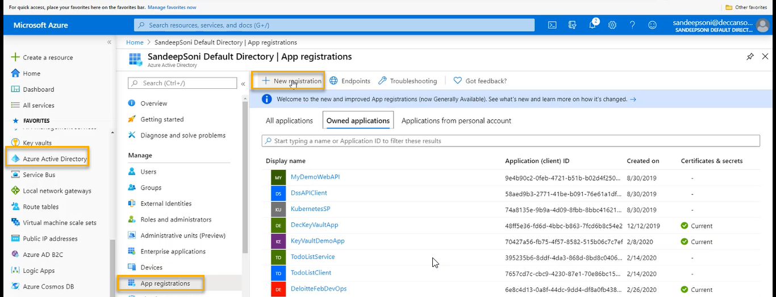

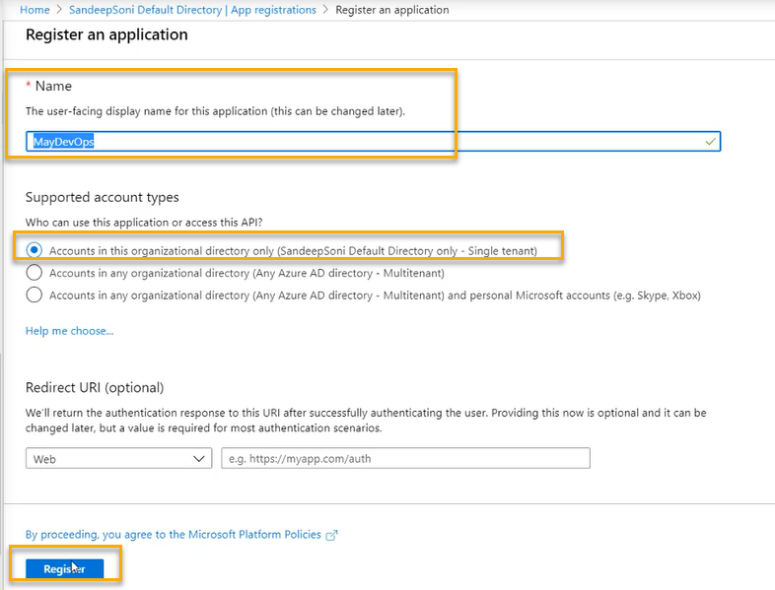

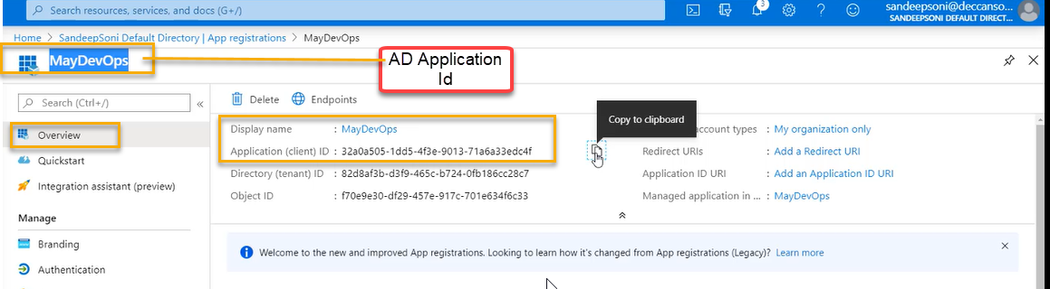

Application Id is called service principal Id

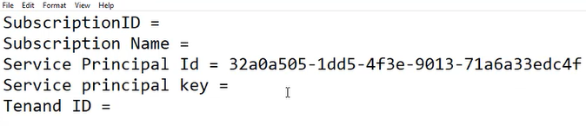

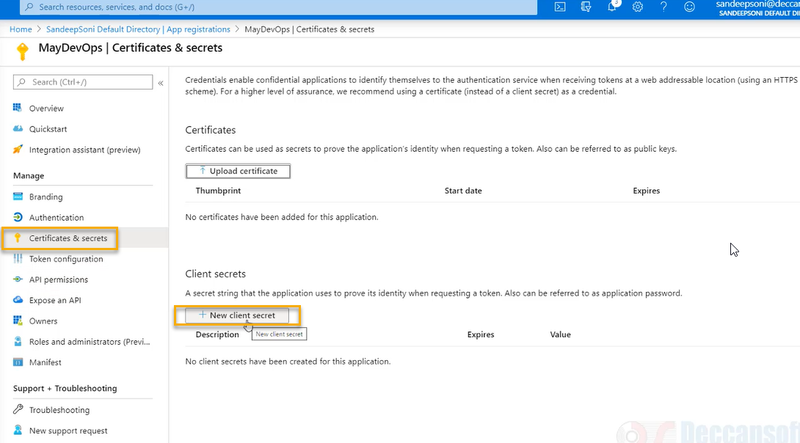

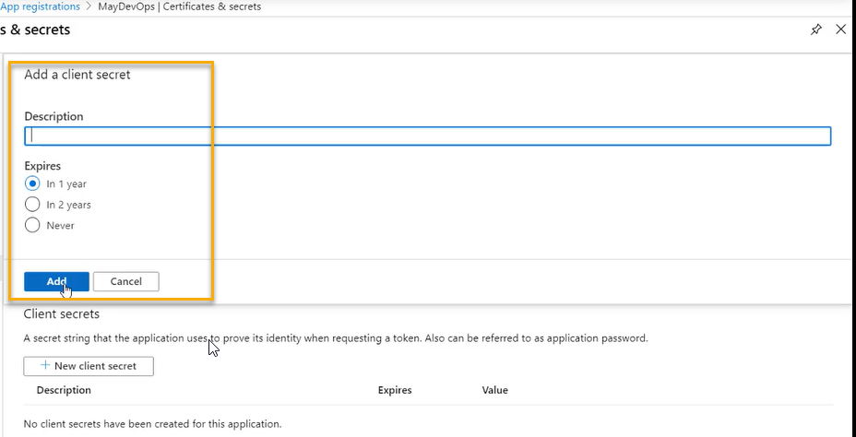

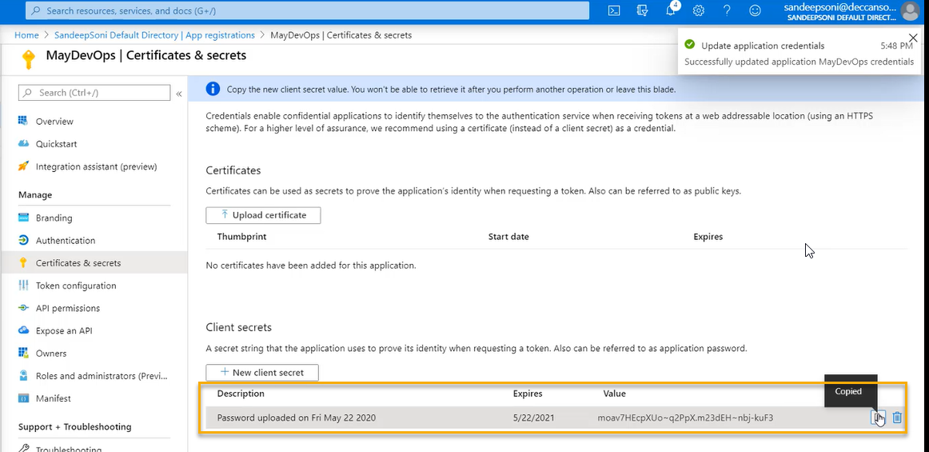

You are NOT supposed to expose the service key to anyone.

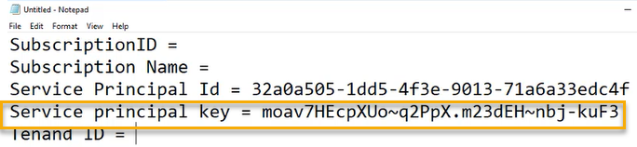

Now go to the below one

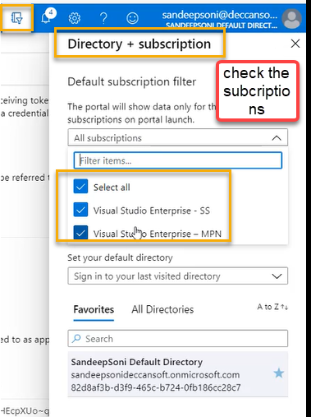

And you should be in the respective directory

Click on show diagnostics

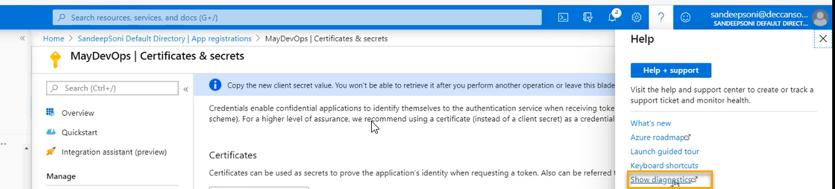

A Json file will be created



The below highlighted is Tenant Id

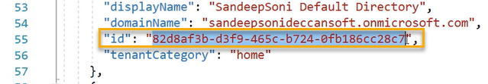

Below is my subscription ID

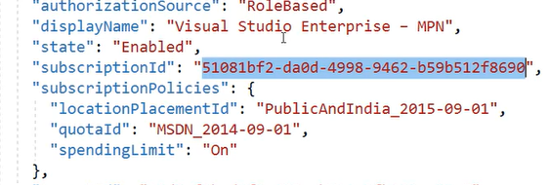

Below is my subscription name

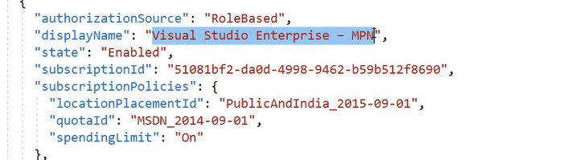

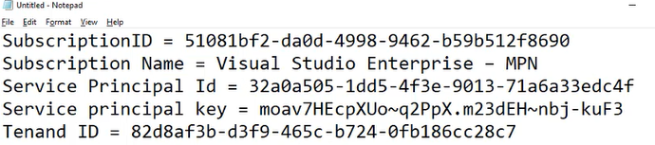

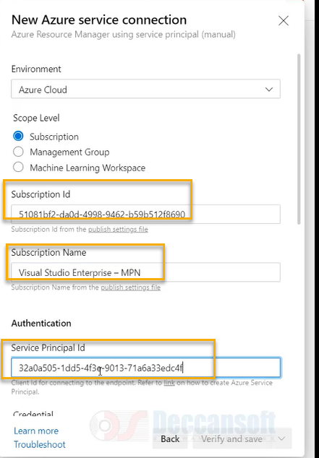

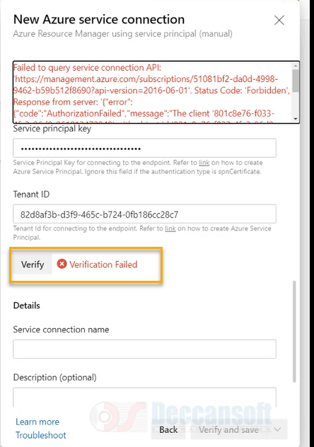

If you click on the verify it is failing the problem is we have created the service principle but we don’t permission to service principle over the subscription

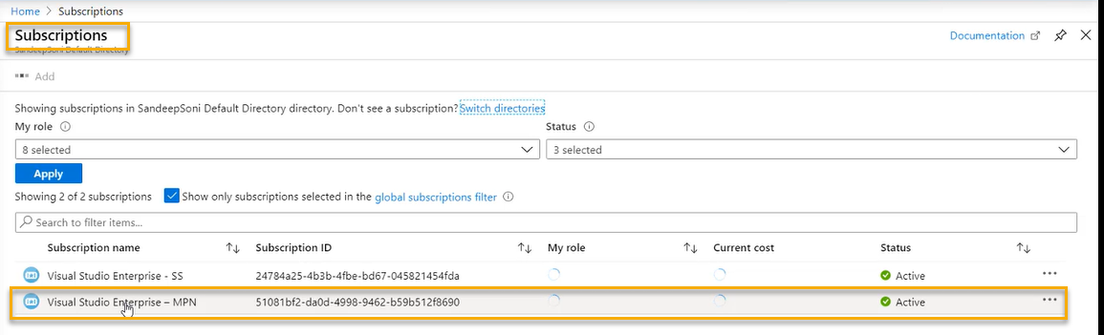

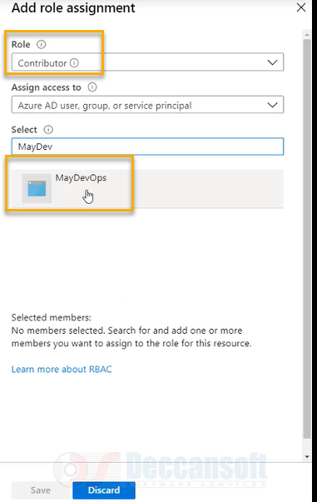

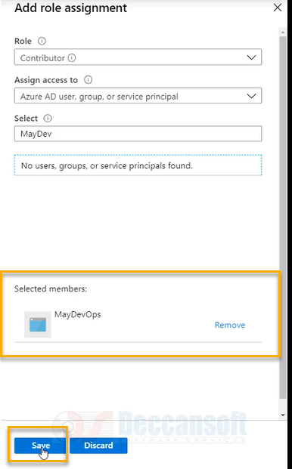

The service principle May DevOps is made as contributor to Visual Studio Enterprise

And if you still get an error then create another secret key

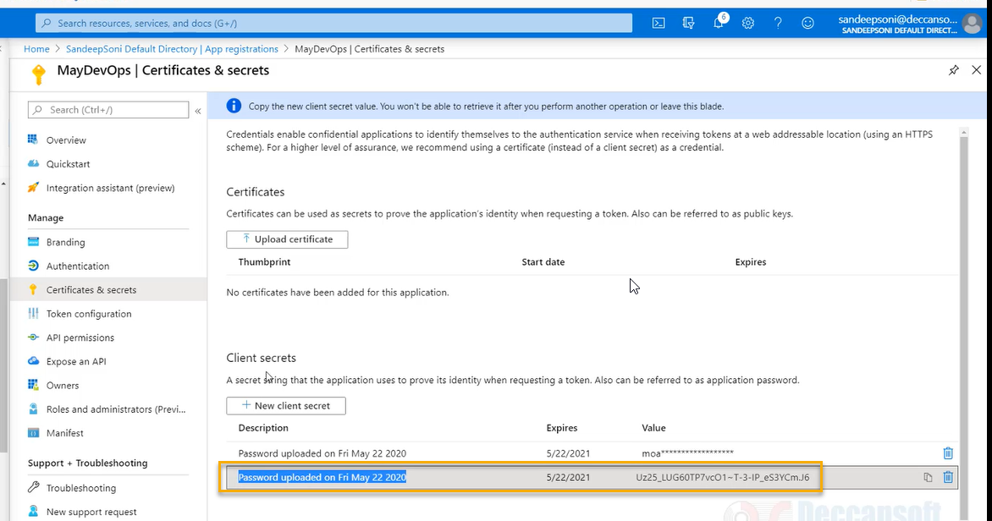

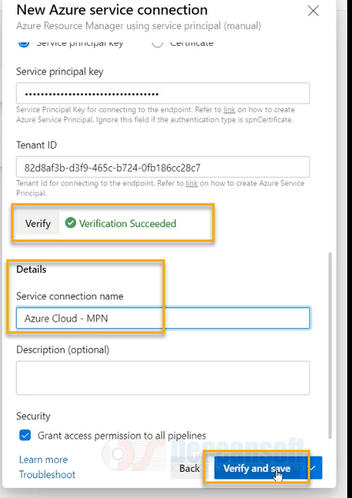

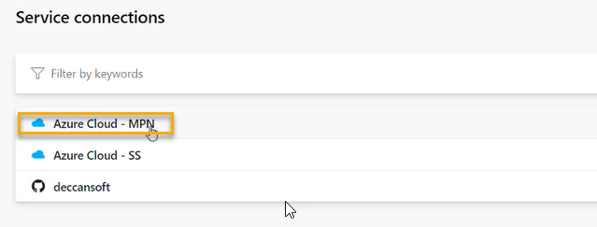

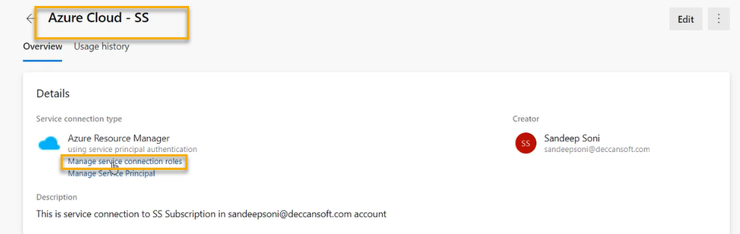

If you click on the above highlighted one it will directly redirect to Azure Portal

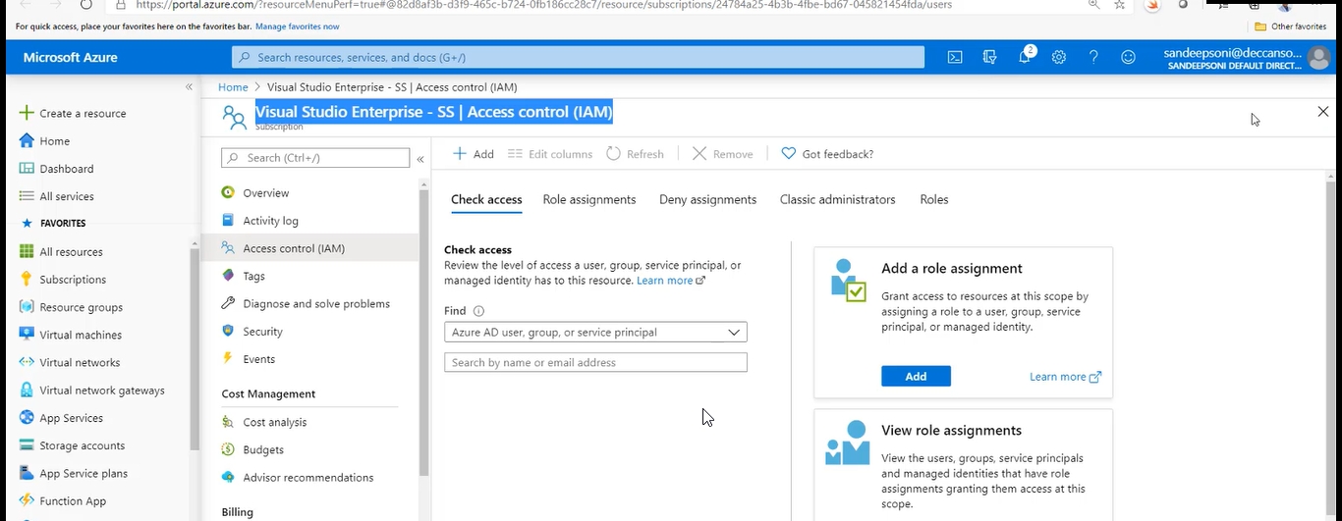

Because we are using same logins for both Azure DevOps and Azure Portal

How it does not work if you will use different logins for Azure DevOps and Azure Portal

In that case go to the below navigation

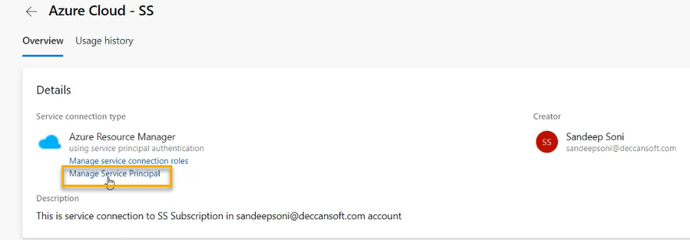

It will directly go the AD

You can configure Azure Virtual Machines (VM)-based agents with an Azure Managed Service Identity in Azure

Active Directory (Azure AD). This lets you use the system assigned identity (Service Principal) to grant the

Azure VM-based agents access to any Azure resource that supports Azure AD, such as Key Vault, instead of

persisting credentials in Azure DevOps for the connection

Ensure that the VM (agent) has the appropriate permissions. For example, if your code needs to call Azure

Resource Manager, assign the VM the appropriate role using Role-Based Access Control (RBAC) in Azure AD.

We can restrict the pipelines from the below navigation.

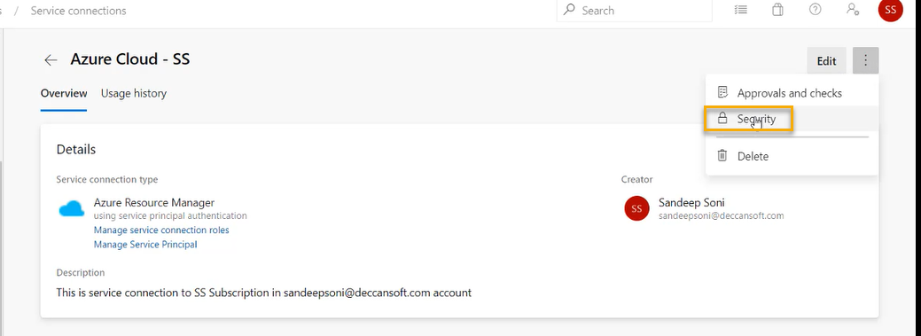

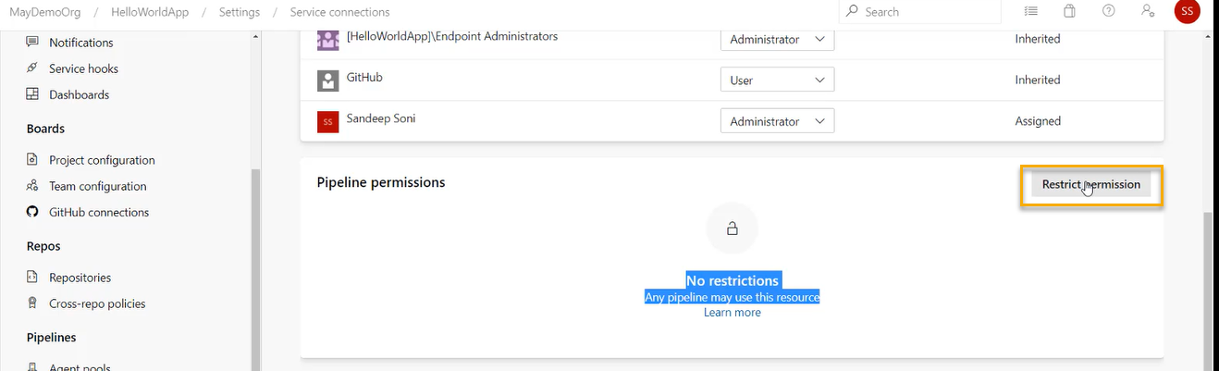

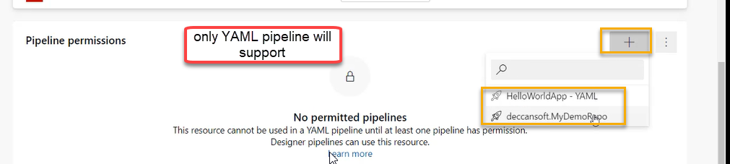

And if it is classic the user who are creating the classic pipeline should have permission below then only he can manage the pipeline

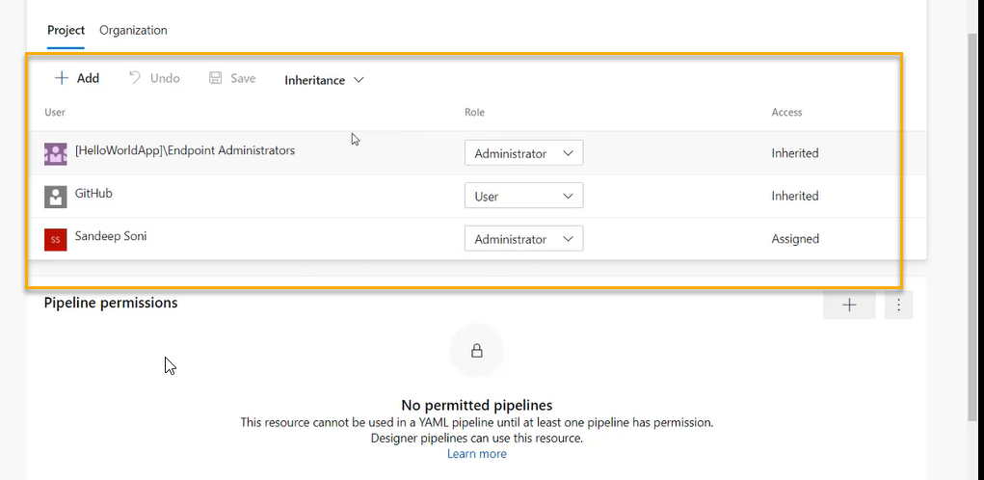

Creating App Services Environments

Deploy ASP.NET Core Application to Azure App Service using Designer

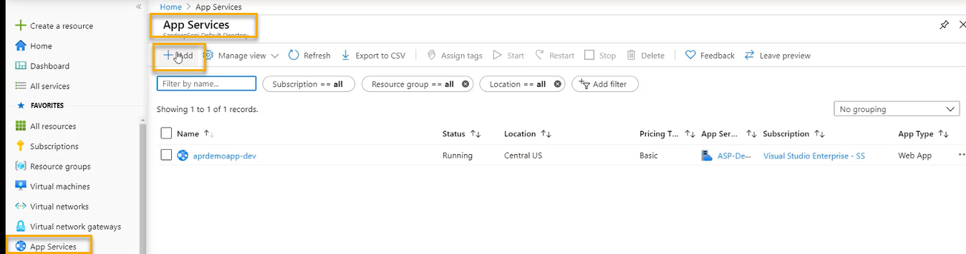

Create three App services for dev, QA and Prod

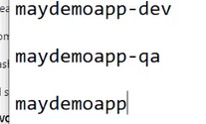

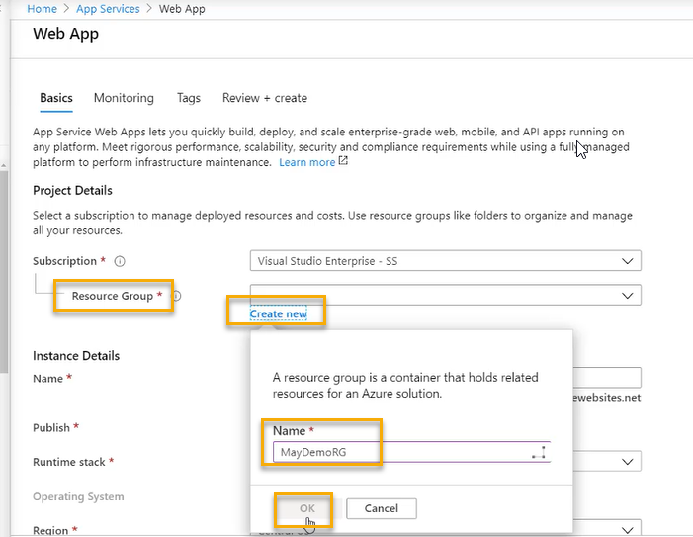

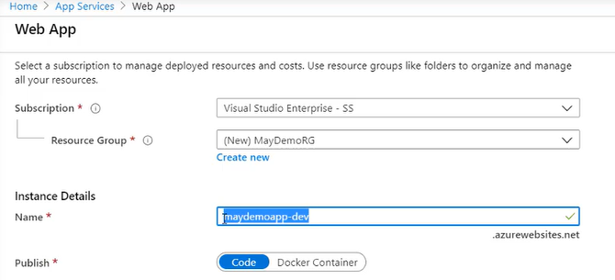

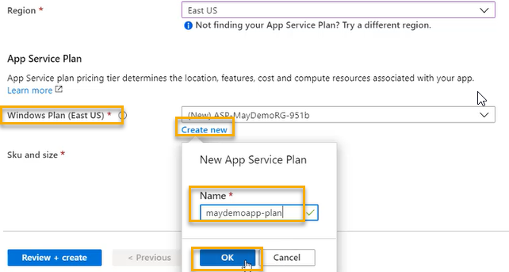

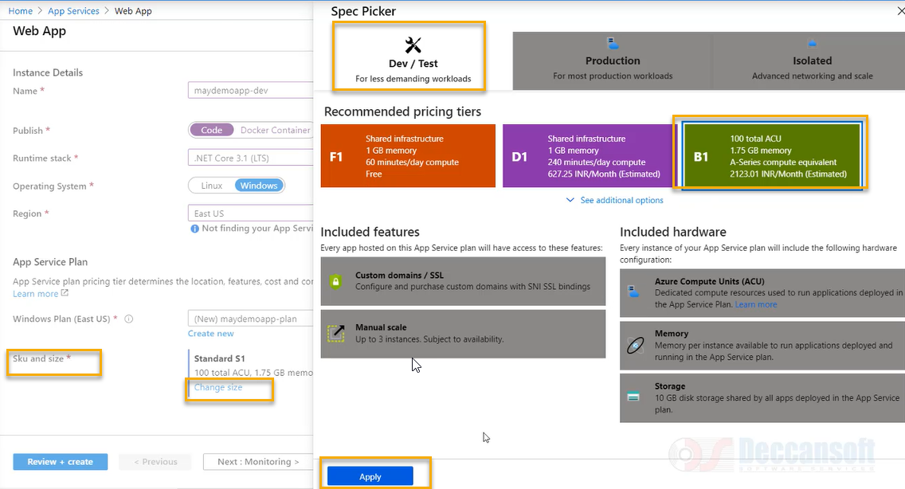

Click on Monitoring

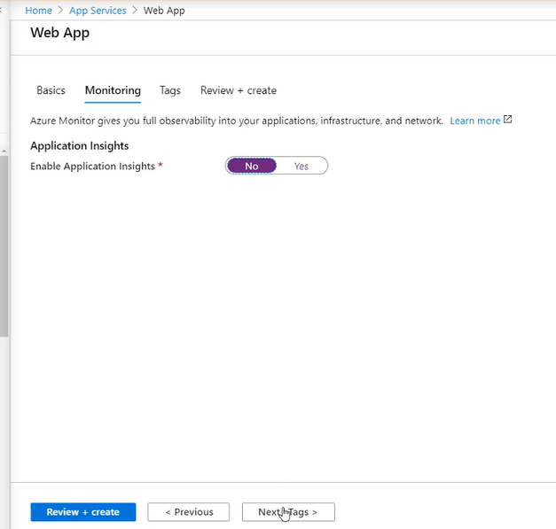

After click on Tags click on Review and create

Again create another App service but name we need to give as qa( creating for qa)

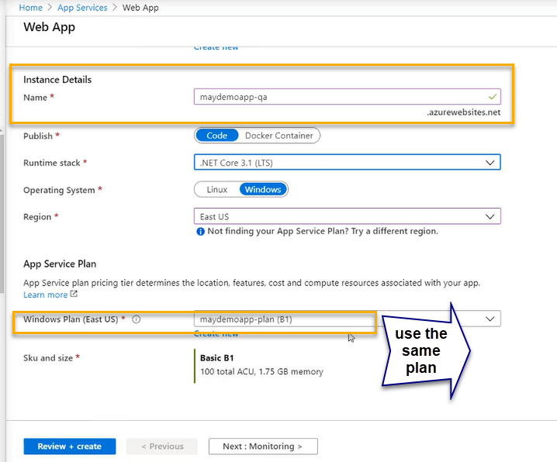

Create another App service for prod

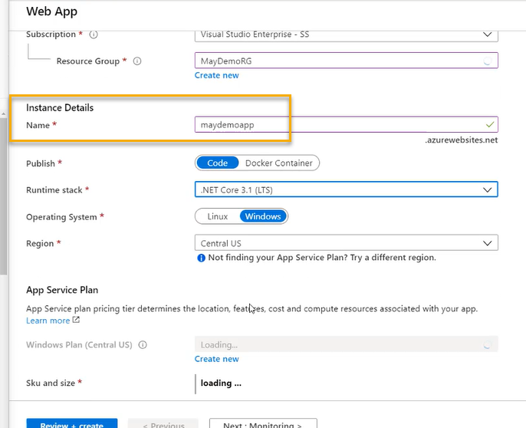

In general ( real time scenario)for Prod we need to another service plan however for qa and dev we can use the same service plan but for practise we can use the service for three of them

We need to create the deployment slot for prod to ensure that there should be no down time for publish

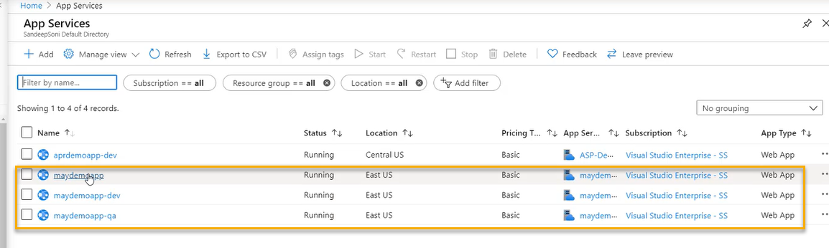

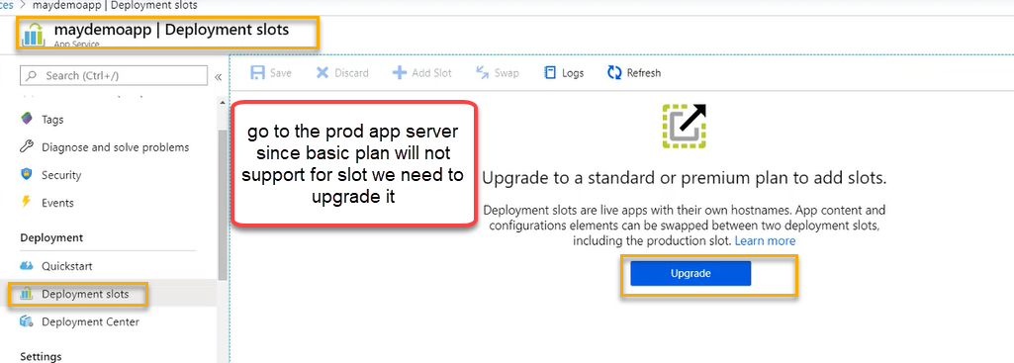

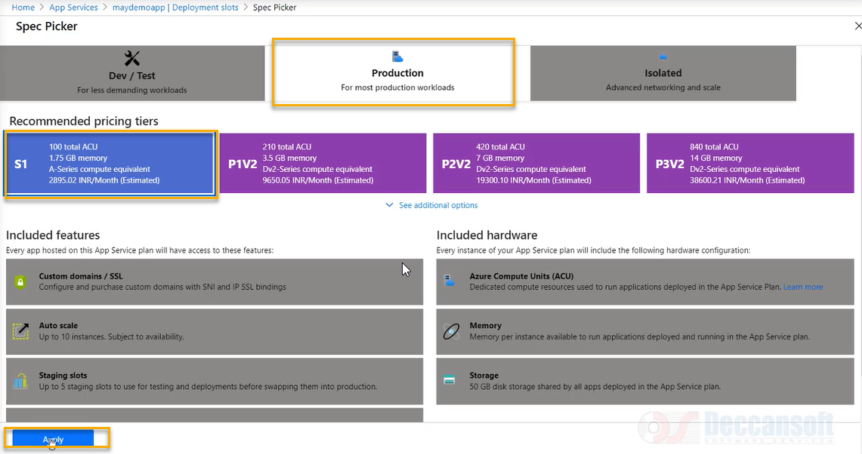

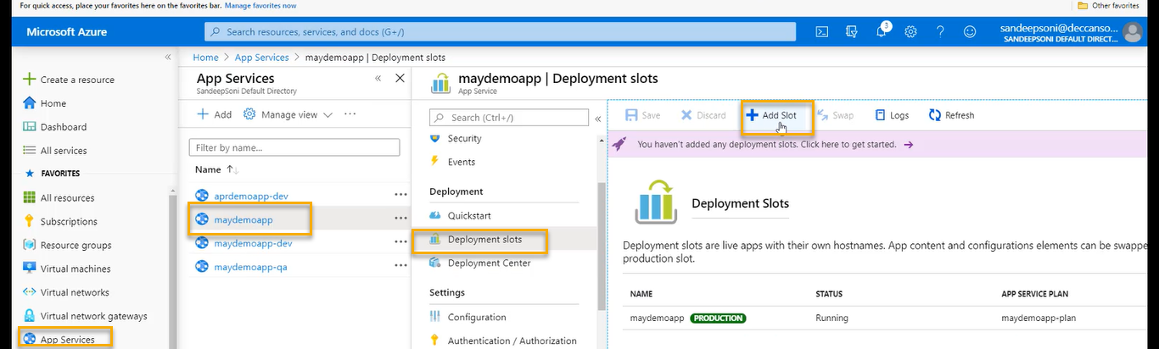

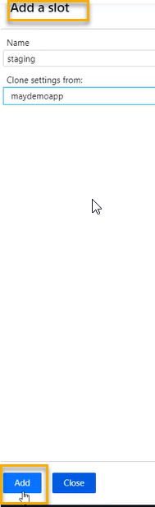

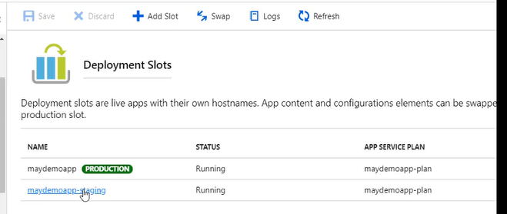

Publishing to App Service from CI Pipeline

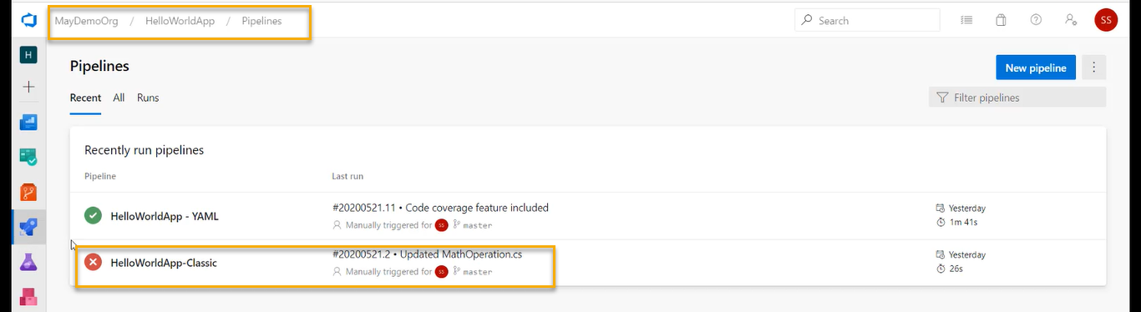

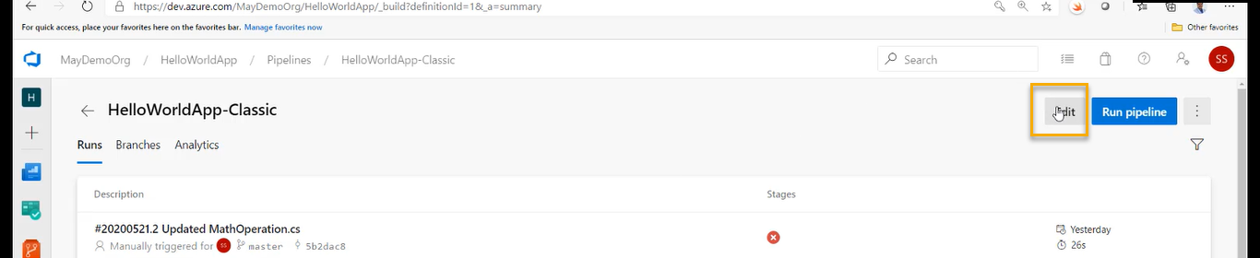

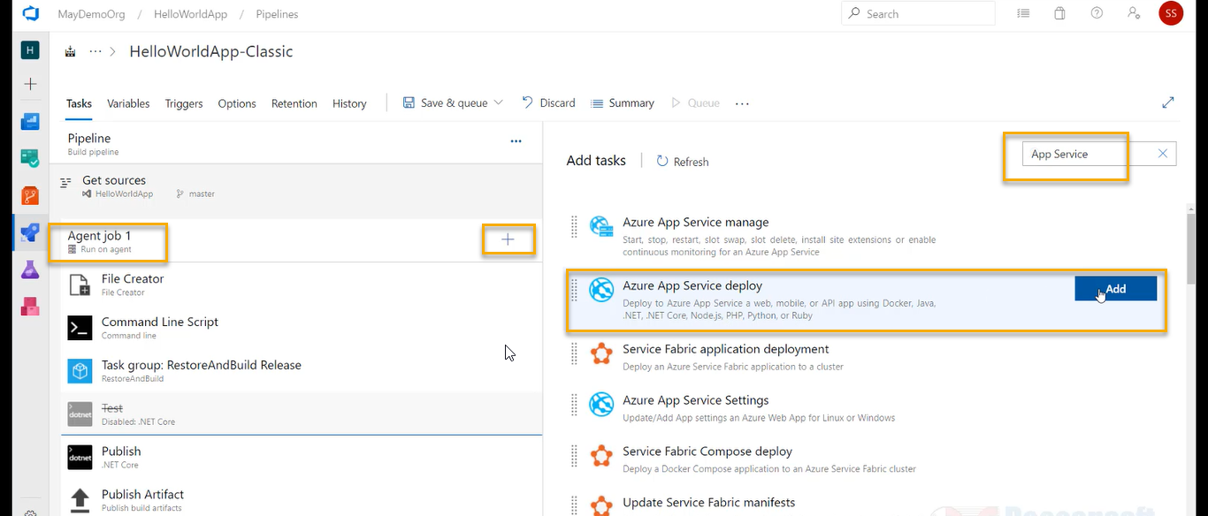

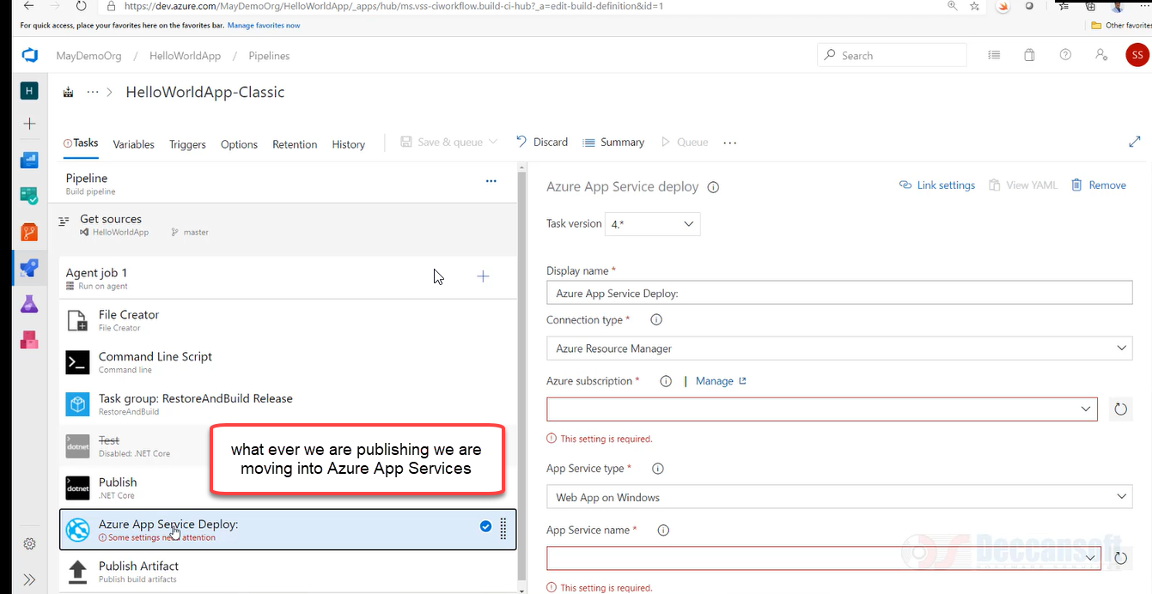

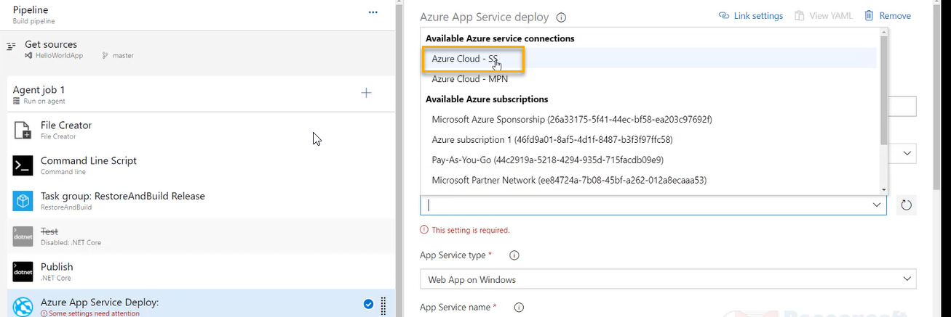

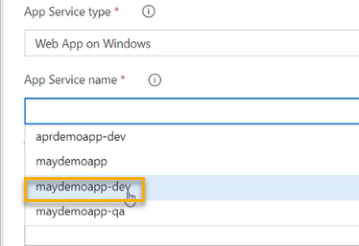

After publishing the output will be stored in the below ones as highlighted below

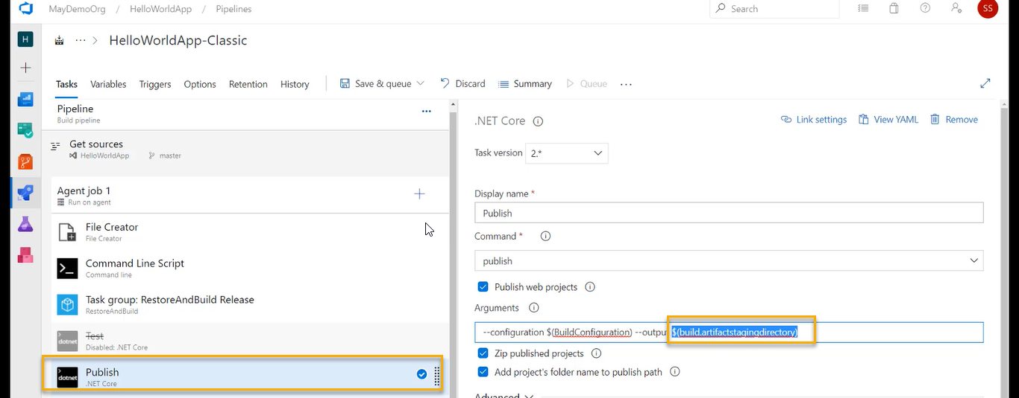

And in the AppService’s we need give the same as highlighted below

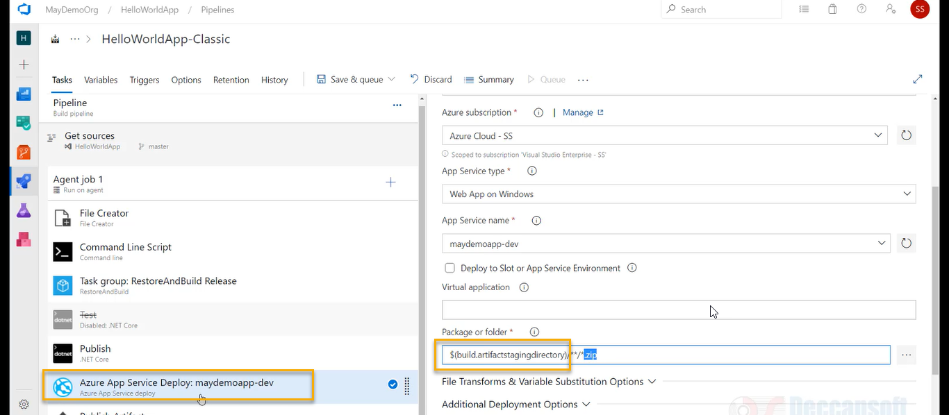

We can disable the publish artifact however the above process we are doing is wrong thing and NOT a good practise

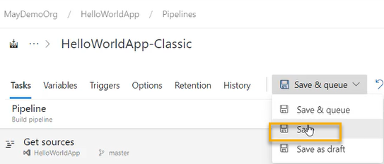

A pop will come and Again click on save

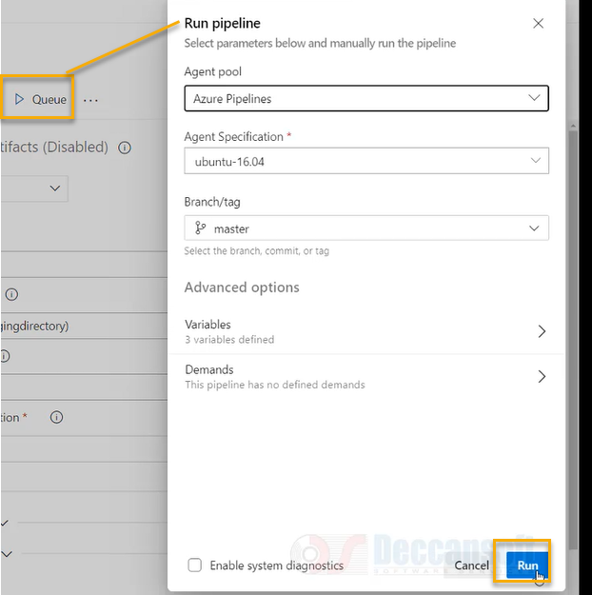

Now go to Azure App services

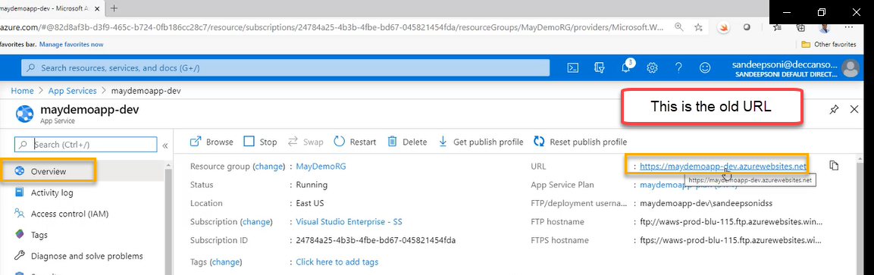

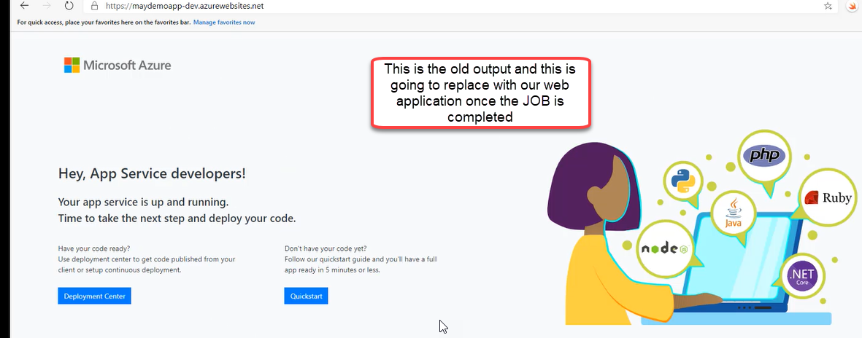

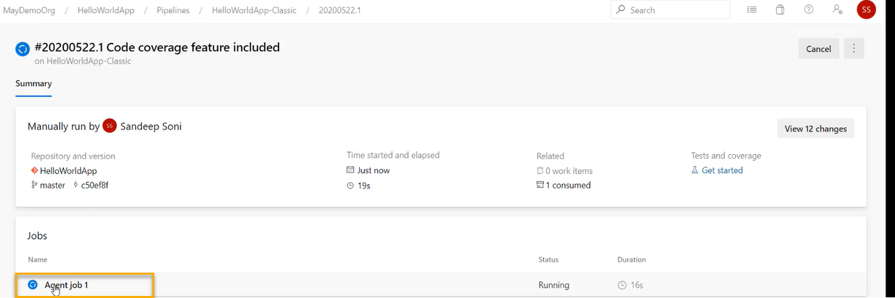

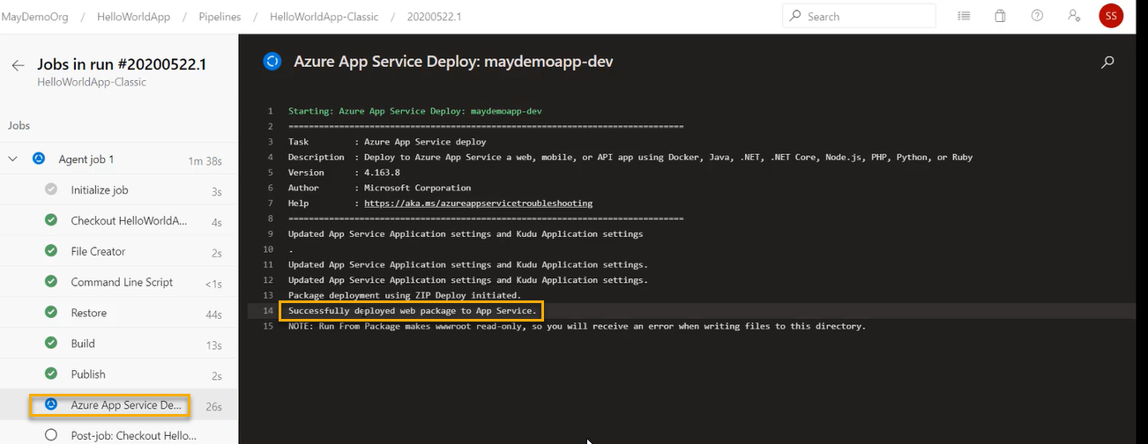

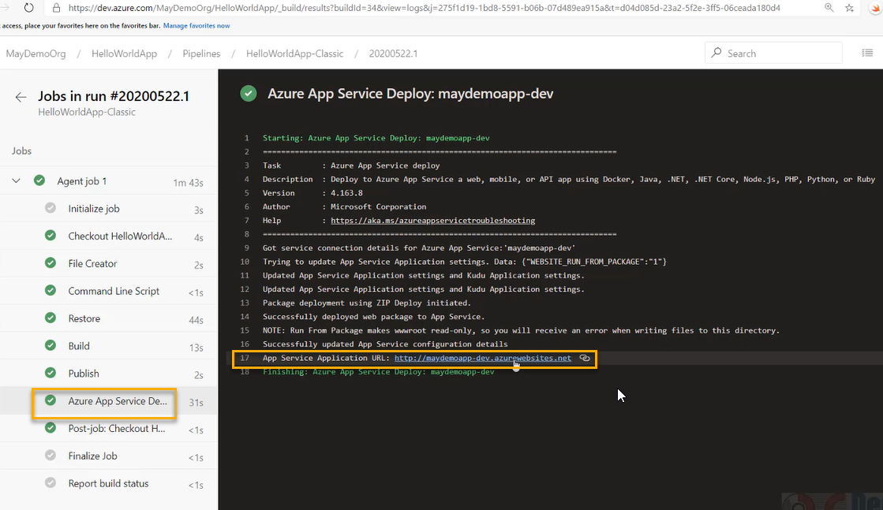

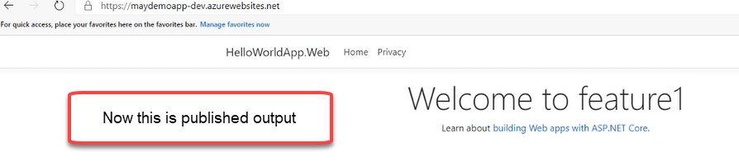

We are doing deployment from CI Classic pipeline

And if you are doing with YAML pipeline

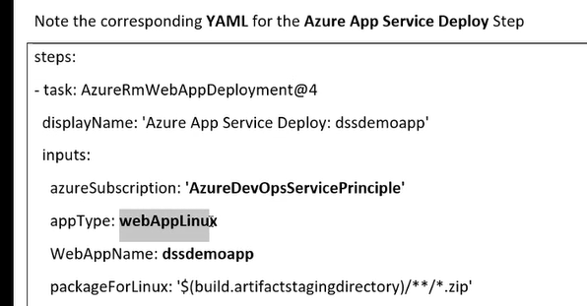

We don’t have CD pipeline at all